## Hospital and Community Care

###Summary

This section includes acute hospital data, delayed discharge bed days and A&E attendances.

**For the most recent time periods available, Moray had:**

* **8,054** emergency hospital admissions per 100,000 population, compared to 10,367 in Scotland.
* **72,871** unscheduled acute specialty bed days per 100,000 population, compared to 77,178 in Scotland.
* **27,226** A&E attendances per 100,000 population, compared to 26,382 in Scotland.
* **59,343** delayed discharge bed days per 100,000 population aged over 65, compared to 50,362 in Scotland.
* **1,769** emergency hospital admissions from falls per 100,000 population aged over 65, compared to 2,285 in Scotland.
* **80.5** emergency readmissions (28 day) per 1,000 discharges, compared to 102 in Scotland.
* **1,197** potentially preventable hospital admissions per 100,000 population, compared to 1,639 in Scotland.

#####Pagebreak

### Emergency Admissions

####Figure 1: Emergency admissions by geographical area

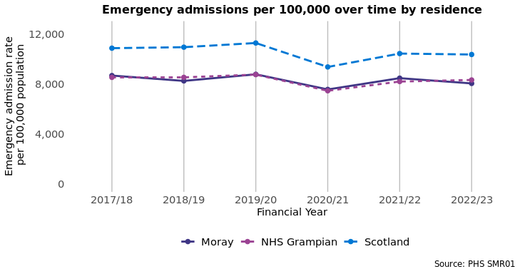

####Figure 2: Emergency admissions by age group

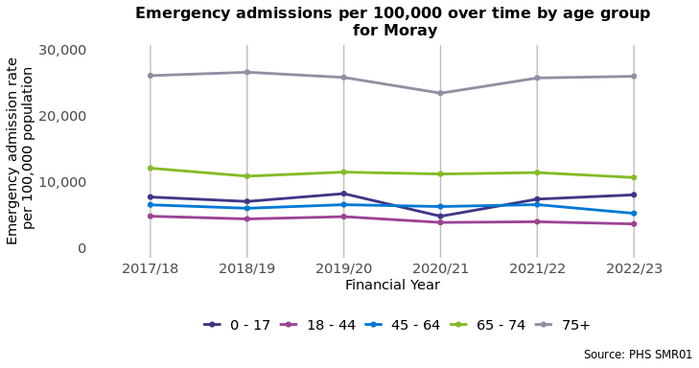

##### Page break

### Unscheduled Acute Bed Days

####Figure 3: Unscheduled acute bed days by geographical area

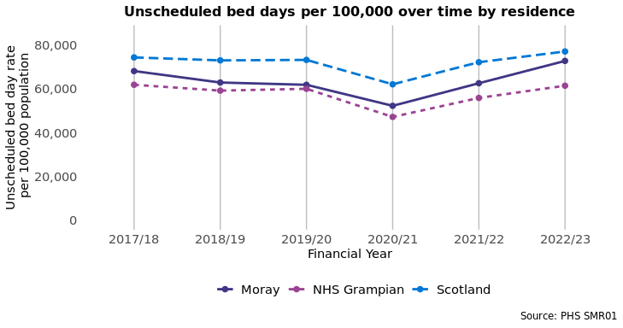

####Figure 4: Unscheduled acute bed days by age group

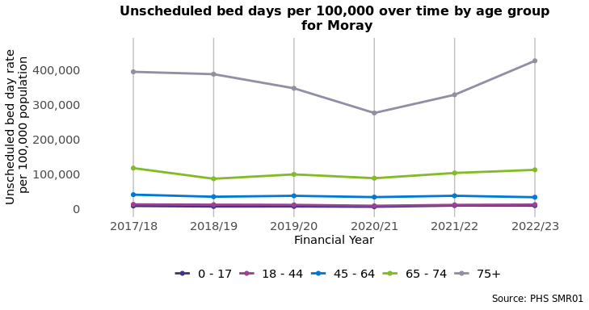

##### Page break

### A&E Attendances

####Figure 5: A&E attendances by geographical area

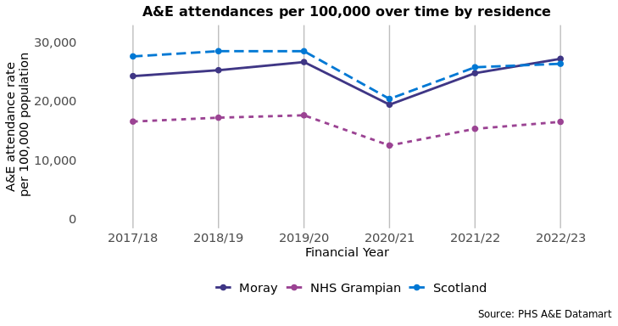

####Figure 6: A&E attendances by age group

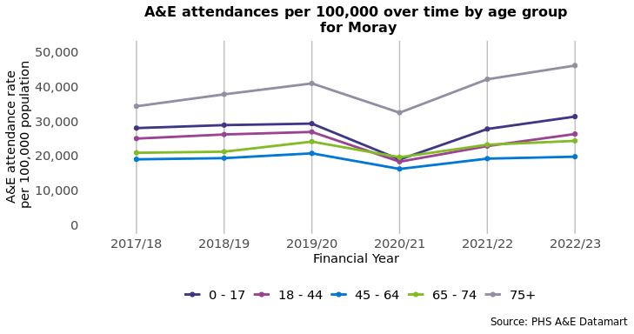

##### Page break

### Emergency Readmissions (28 days)

####Figure 7: Emergency readmissions (28 days) by geographical area

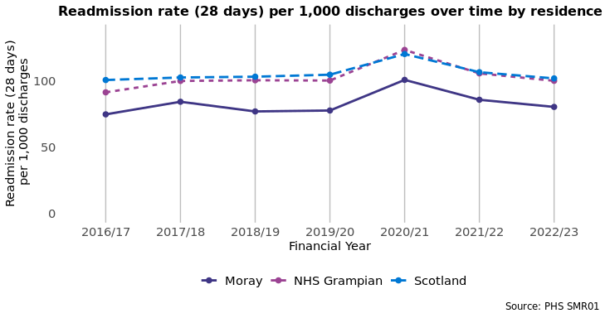

####Figure 8: Emergency readmissions (28 days) by age group

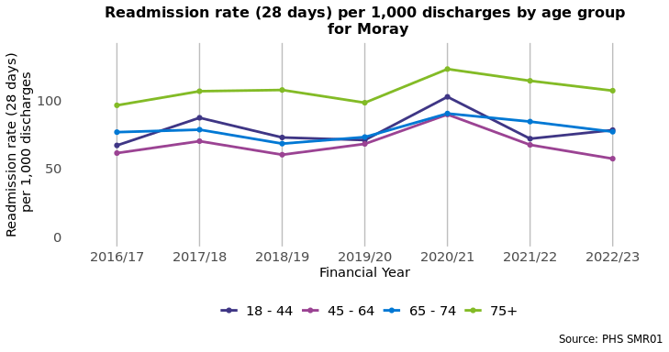

##### Page break

### Delayed Discharge Bed Days

####Figure 9: Delayed discharge bed days in population aged 65+ by geographical area

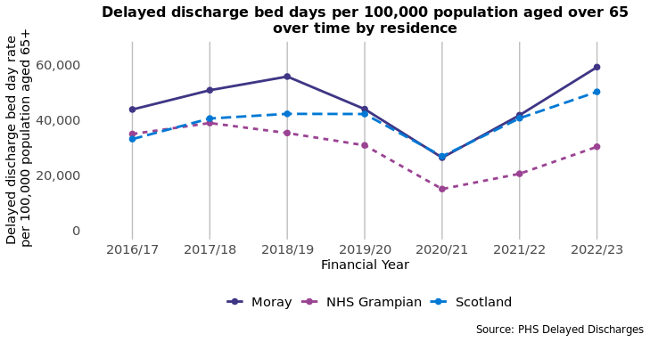

### Emergency admissions from a fall

####Figure 10: Falls in population aged 65+ by geographical area

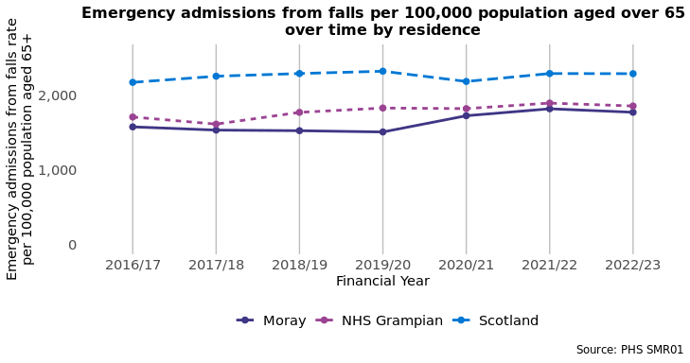

##### Page break

### Potentially Preventable Admissions (PPAs)

Information on the conditions included in PPAs is available in Appendix 3. In 2022/23, **50.3%** of PPAs in Moray were amongst those aged 65 and over, and **49.7%** were amongst those aged under 65.

####Figure 11: PPAs by geographical area

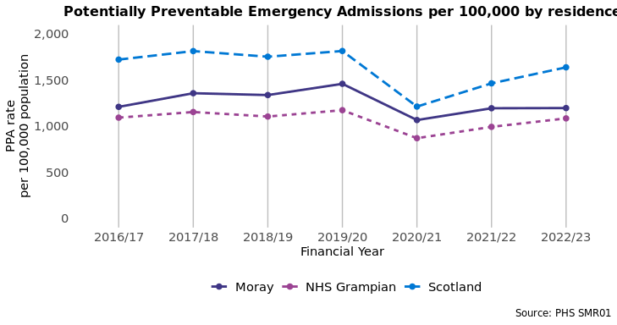

##### Page break

## Hospital Care (Mental Health Speciality)

###Summary This section looks at mental health related unscheduled care indicators.

**For the most recent time periods available, Moray had:**

* **191.4** psychiatric patient hospitalisations per 100,000, compared to 230.7 in Scotland4.
* **10,222** unscheduled mental health specialty bed days per 100,000, compared to 18,735 in Scotland.

### Psychiatric patient hospitalisations

####Figure 12: Psychiatric patient hospitalisations by geographical area

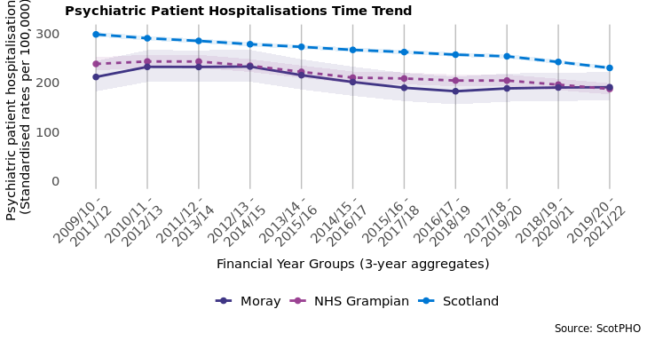

##### Page break

### Unscheduled Mental Health Specialty Bed Days

####Figure 13: Unscheduled mental health specialty bed days by geographical area

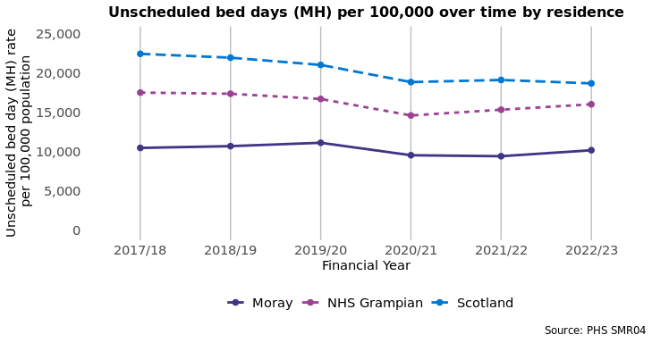

####Figure 14: Unscheduled mental health specialty bed days by age group

